Does the market price the Fed’s own rule?
USD and GBP policy paths, 2014–2026

Summary
Is the market pricing the Fed’s own rule? No. In USD, in every year since 2014, the market has priced the Fed 25 to 86 bp easier than its own rule about five months out, or one to three and a half quarter-point moves. When the two disagreed, the Fed tended to move toward the market.
Even so, the gap is not a tradable signal. Once that gap is standardized (z), it does not forecast rate changes in USD, and points the wrong way there. In GBP, where the same rule is applied to UK inputs, the story is different: it does forecast them, but the gains are concentrated in one window (2022–2023). The book’s rate calls earned on balance, but not enough to pay for carry and roll, so it loses money before costs. About half of the costs are upkeep rather than the signal: rolling each position to a new contract as meetings pass, and re-striking (resetting) the curve trades’ bond legs each quarter.
For each currency I measure the path the market was pricing against the path the rule gives. The difference (the gap) is taken at the 4th meeting ahead for each central bank, about five months out, and standardized as a z-score on a trailing 2-year window after a year of history. The z is scored by its rank correlation (IC) with the policy-rate change over the next 5, 21 and 63 sessions (about a week, a month, and a quarter), outside the effective lower bound (ELB), when the policy rate and the rule are both at the floor.
Four findings
- The level. The market prices the policy path persistently below the Fed’s own published rule: in USD, this is in every one of the 13 years, by 25 to 86 bp at the 4th meeting. That is one to three and a half quarter-point moves less tightening than the rule.
- The signal. The gap does not forecast at the book level, and in USD it points the wrong way (IC(21) −0.12): when the two disagreed, the policy rate moved toward the market over the next month, and the FOMC’s dots moved about two-thirds of the way toward the market within a quarter.
- GBP is the exception. GBP outright forecasts (IC(21) +0.38) and earns (net Sharpe ratio +0.50), but outside 2022–2023 it nets +0.04, and it depends on an r* fixed with hindsight, so I do not claim it as a tradable signal.
- The costs. The rate calls earned 1.36% of capital a year, but carry and roll cost 2.08% and trading 2.47%, so the book loses before costs (Sharpe ratio −0.14) and after (−0.60). Maintenance (rolls and re-strikes) is 46% of the cost; rolls alone, which are forced by trading the 4th meeting ahead, are 33%. Neither the carry filter nor any single choice in the robustness grid turns it positive.

Why this question
The reference path is the Fed’s own published rule (in its Monetary Policy Report), so there are no free parameters to tune and it’s auditable. The Bank of England publishes no such rule, and for GBP, the same rule was applied to UK inputs.
There is significant value in testing a rule of this nature. If the market ignored a rule the Fed itself publishes, that would say something about how much the rule guides policy. The answer runs the other way: the gap closes because the Fed moves toward the market.

Definitions
Term | Definition
USD r* | SEP (Summary of Economic Projections) longer run median; Taylor’s 2% before the first SEP (226 Sessions)
GBP r* | Constant −1.6% which is the average real Bank Rate from 2009–2026. A hindsight number. It moves the bp gap and mostly leaves z unchanged, except near the floor
z | The gap (market minus rule) at the 4th meeting ahead, standardized against its trailing 2-year window after 1 year of history
IC | Rank correlation of z with the rate change over the next h sessions (5, 21, 63) outside the ELB State. IC is signed in the trade's direction: positive means the gap closed as the trade bet.
ELB State | Effective lower bound: the policy rate and the rule both at the floor. The book is flat there
Hysteresis Rule | Enter at |z| ≥ 1, exit at 0; fixed before results
Book | The sleeves held together as one portfolio
Book Construction | Inverse-vol weights, shrunk covariance, 5% vol target on the whole book, no drawdown control
Roll | Moving an outright position to the new fourth-meeting contract each time a meeting passes
Re-strike | Replacing the par bond legs of the curve and cross sleeves with new par bonds each quarter
Carry and roll | What a position earns over a period if the curve does not move
LFS | Labour Force Survey
DV01 | Dollar Value of a 1 basis point move
Sleeve | One traded expression of the signal, e.g. USD outright

Construction
The market path is solved from fed funds futures (ZQ) for USD and read off the Bank of England’s fitted OIS curve for GBP, eight meetings ahead. Each is checked against independent prices: the USD path agrees with SOFR futures to within about 2 bp, and the GBP path is within 1 bp of the Bank’s own published conditioning paths on average across 29 reports. Appendix A sets out the construction and both checks.
The signal is read at the 4th meeting ahead, about five months out. That is far enough out that the market is pricing a forecast, not a decision the Fed has already signalled, and near enough that the futures are liquid and holding the rule’s inputs flat is still a fair approximation. Its cost is a forced roll each time a meeting passes, which section 7 measures.

The rule and r*
One of the rules that the Fed publishes in its Monetary Policy Report is the balanced approach rule. It is a variant of the Taylor Rule. It carries a 2 on the unemployment gap which is double the Taylor Rule and is symmetric.
$R^{*}=r^{*}+π+0.5\left(π-2\right)+2\left(u^{*}-u\right)$ (1)
$R_{k}=0.922⋅R_{k-1}+0.078⋅\max\left(ELB,R^{*}\right)$ (2)
with R₀ the rate in force.
The MPR’s inertial rule uses 0.85 per quarter, which is the weight on the last period’s rate: 0.922 per meeting (sqrt (0.85)). I held today’s inputs as flat across the path and asked: where does the rule take policy?

Real-time inputs
Each input is what was published on the day. Beginning with π, which is the 12-month core PCE, bridged from CPI for months PCE hasn’t printed yet. I tested the accuracy of this bridge and the test returned a RMSE of 0.075 pp against PCE’s first print over 185 months. u* is CBO’s estimate as vintaged on that day, from ALFRED (Figure 1). A test reruns the whole chain cut off on day D, then appends deliberately corrupted data after D and checks that nothing on or before D moves.
For GBP the inputs are headline CPI (12 month, the MPC’s target), LFS unemployment as first printed, and constants for u* (4.5%) and r* (−1.6%). Importantly, this is headline CPI and not core as this is what the MPC targets.
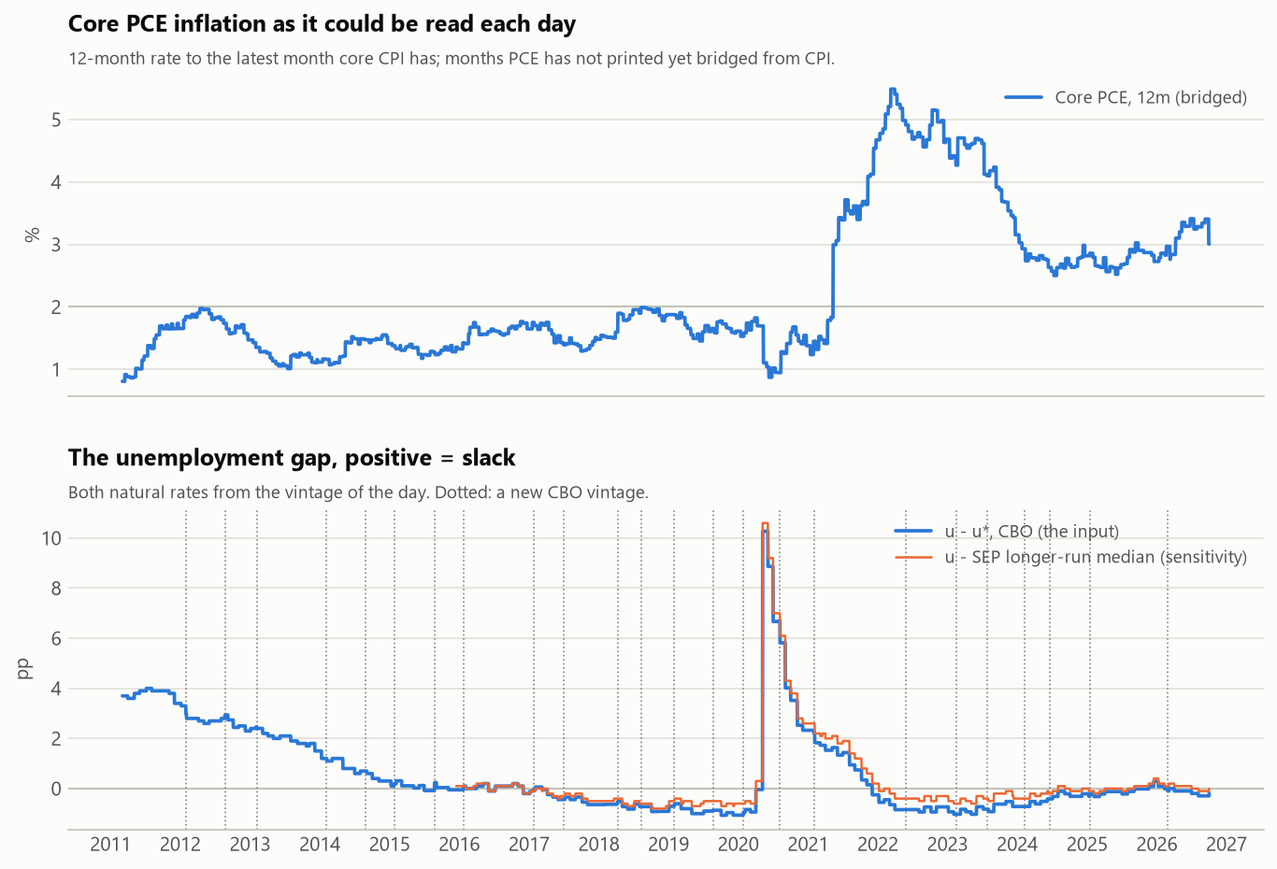
Figure 1. Real-time USD rule inputs: core PCE inflation as it could be read each day, and the unemployment gap.

r* choices
Each SEP is a dated document that is never revised, so it is real time without any vintage machinery. This isn’t the same for GBP, which uses a constant −1.6%, the average real Bank rate. Both values are tested later in Robustness using HLW (Holston-Laubach-Williams r*) in real time for USD (book net Sharpe ratio −0.52) and constants ±1 pp for GBP (−0.58 and −0.63).

The level
The market trades persistently below the rule. For the USD, that’s 13 out of 13 years outside the ELB, by −25 bp to −86 bp (Figure 2). By regime that is −37 bp hiking, −53 bp on hold, and −62 bp cutting. In effect, this matches the pattern of the market pricing below the FOMC’s dots.
Why the market prices below the rule is not something this measurement identifies, but it narrows the answer. The risk premium documented in fed funds futures is positive on average (Piazzesi and Swanson, 2008), which would put the market above the rule, not below it. That points to the market doubting that the Fed will follow the rule, or to the rule itself being off: its r*, or inputs held flat while inflation falls. Running the rule on the FOMC’s own projections of inflation and unemployment, rather than flat inputs, would test the second directly.
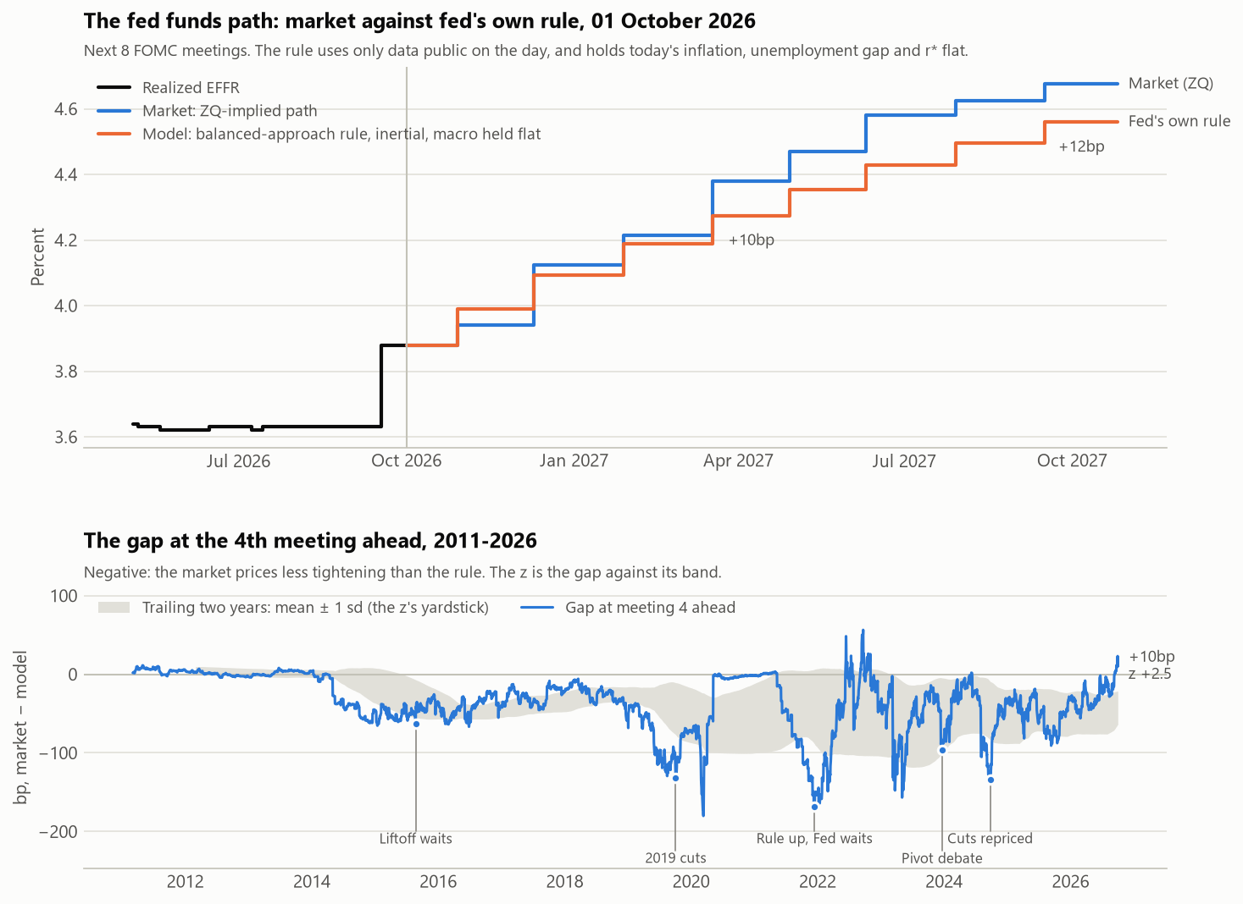
Figure 2. USD: the market path against the balanced-approach rule, and the gap at the fourth meeting ahead.
The gaps are larger for GBP (−122 to +102 bp; Figure 3). It isn’t persistent; it depends on the regime: −81 bp while hiking, +28 bp while cutting. It sat below the rule in 8 of 11 years, then above from 2024 (+36, +19, +102 bp). With a fixed r*, the post 2024 flip is as consistent with r* being wrong as with the market repricing, and this measurement can’t separate them.
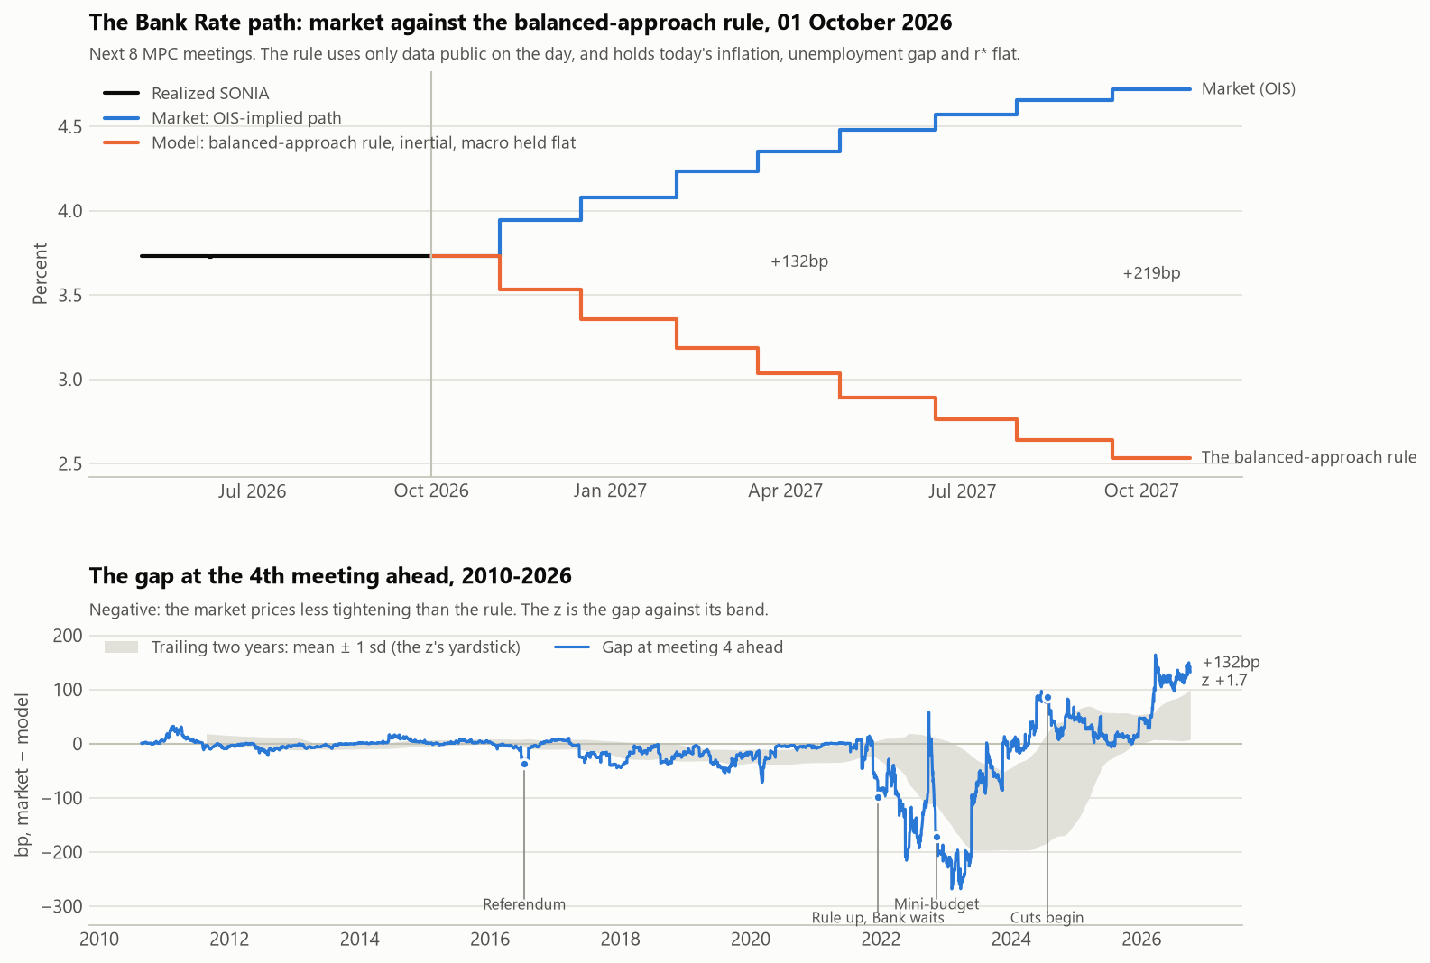
Figure 3. GBP: the market path against the balanced-approach rule, and the gap at the fourth meeting ahead.

The signal and the null
The USD gap has no forecasting value and instead points the wrong way (Figure 4, Table 1). USD outright is not successful, with a −0.12 for IC (21) across 2,930 sessions. The results for GBP are strong, with GBP outright seeing +0.38 in IC (21). This result is across 2,273 sessions and carries a t-stat of 4.7. The three curve and cross sleeves are small (|t| ≤ 1.6). Outside GBP outright, nothing here rejects the null.
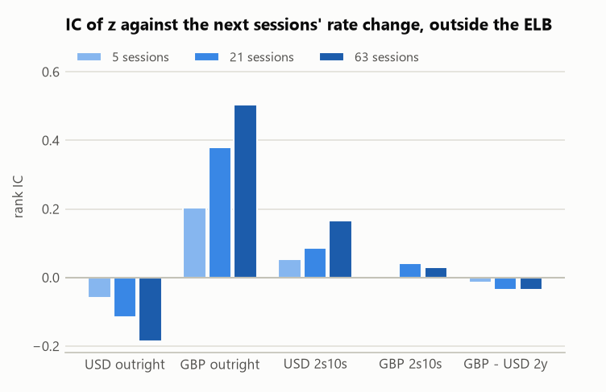
Figure 4. IC of z against the next 5, 21 and 63 sessions’ rate change, outside the ELB.
Table 1. IC of z against the rate change over the next h sessions, outside the ELB.
Sleeve | IC(5) | IC(21) | IC(63) | Sessions (21) | Non-overlapping IC(21)
USD outright | −0.059 (−1.7) | −0.116 (−1.7) | −0.185 (−1.5) | 2,930 | −0.115 [−0.18, −0.06]
GBP outright | +0.203 (+4.7) | +0.380 (+4.7) | +0.505 (+4.1) | 2,273 | +0.378 [+0.32, +0.43]
USD 2s10s | +0.055 (+1.6) | +0.088 (+1.3) | +0.167 (+1.4) | 2,930 | +0.088 [+0.02, +0.17]
GBP 2s10s | −0.001 (−0.0) | +0.043 (+0.6) | +0.029 (+0.3) | 2,273 | +0.043 [−0.05, +0.13]
GBP − USD 2y | −0.015 (−0.4) | −0.035 (−0.4) | −0.036 (−0.3) | 2,195 | −0.033 [−0.11, +0.01]
Newey-West t in parentheses; the non-overlapping range in brackets.
The t is Newey-West to lag h, but z is persistent, and so the products of z and the rate change stay autocorrelated past h. That results in t overstating the precision. The non-overlapping check gives GBP +0.32 to +0.43, clear of zero, and USD −0.18 to −0.06.
The interpretation from these results is that the market leads the Fed. A negative IC means that when the market sits below the rule, the rule falls towards the market over the following weeks, because the Fed’s rate moves; the market doesn’t rise toward the rule. The dots move towards the market (+0.68 per bp of gap over 63 sessions (t +4.7) against +0.09 (t +0.5) the other way). The gap carries no usable information at the book level; GBP outright is the one exception. As shown later, I do not claim this as a tradable signal.

Performance
The book’s Sharpe ratio is −0.14 gross and −0.60 net (SE 0.32; Table 2): −3.19% of capital per year. The worst drawdown was more reflective of a grind than of a break, 57.5%: April 2014 to September 2021. The worst 21 session loss is only 10.8%. The losses in the book are concentrated in the USD outright, which accounts for −25.9% cumulative (Figure 5).
Table 2. Sharpe ratios (SE), gross and net of costs, and net with 2022 and 2022–23 left out.
Sleeve | Gross SR | Net SR | Net a year | Ex-2022 | Ex-2022–23
Book | −0.14 (0.29) | −0.60 (0.32) | −3.19% | −0.98 (0.37) | −1.11 (0.40)
USD outright | −0.50 (0.31) | −0.88 (0.34) | −2.19% | −1.09 (0.38) | −1.23 (0.42)
GBP outright | +0.73 (0.33) | +0.50 (0.31) | +0.99% | +0.15 (0.31) | +0.04 (0.32)
USD 2s10s | +0.01 (0.29) | −0.12 (0.29) | −0.29% | −0.15 (0.31) | −0.19 (0.32)
GBP 2s10s | −0.36 (0.30) | −0.62 (0.32) | −1.15% | −0.73 (0.34) | −0.58 (0.34)
GBP − USD 2y | −0.15 (0.29) | −0.27 (0.30) | −0.54% | −0.48 (0.32) | −0.62 (0.34)

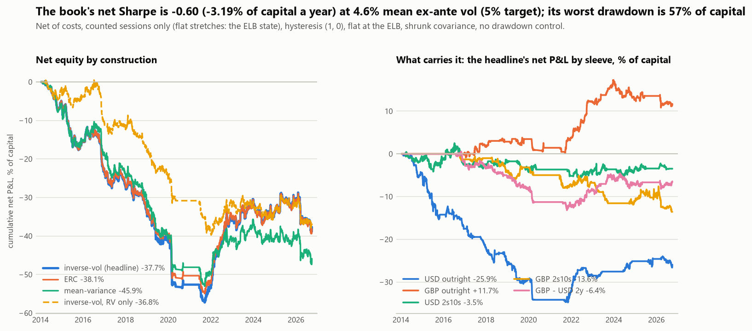
Figure 5. Net equity of the book by construction, and the headline book’s net P&L by sleeve.
GBP outright is the only sleeve that earns, and it earns in one window: net Sharpe ratio +1.76 (SE 0.87) while hiking, on 4 trades; excluding this winning period (2022–2023) it nets +0.04. GBP outright’s success depends on this window, a hindsight r* constant, and is sensitive to the coefficients (+0.67 → +0.13).
63% of the variance of the daily gross P&L is the exposure to the front-end, so the book is closer to a duration timer than it is to a relative value trade. In fact, for the gross P&L, the level exposure earned 0.05% of capital per year, where the rest lost 0.77%. The level sleeves earn +0.22% per year gross and −1.20% net; costs (1.43%) alone turn the level negative (Figure 6). The risk is the level’s; the loss is the rest’s.
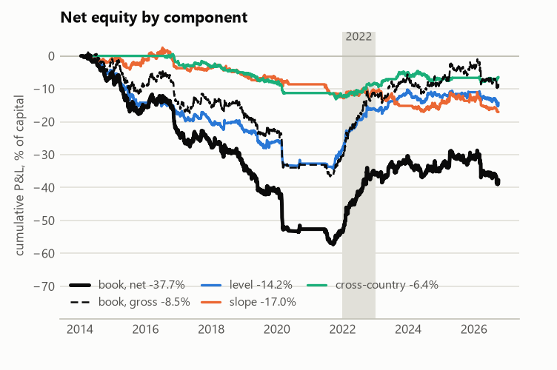
Figure 6. Net equity by component: level, slope and cross-country, with the book gross and net.

Reaction
Nothing was re-tuned in response. The hysteresis pair was set in config before the grid ran. Similarly, the ELB treatment and construction were fixed before the results.

Costs, rolls and breakeven

Costs and the roll
Turnover explains the costs exactly: 19.8 turns a year × 284k per bp of mean gross DV01 × 0.44 bp one way = 2.47% of capital a year, the cost charged.
Maintenance is 46% of the cost. Rolls alone are 33%, and they are forced: each outright trades the 4th meeting ahead, so every time a meeting passes the position moves to a new contract. The par legs are also re-struck every quarter (13%).
Gross is already −0.72% per year. No cost treatment makes the book pay (Figure 7).
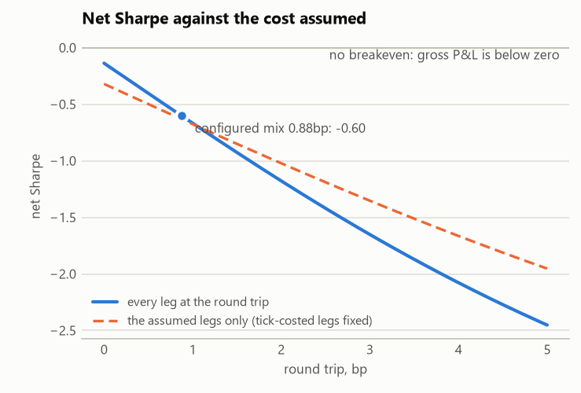
Figure 7. The book’s net Sharpe ratio against the round-trip cost assumed.
Even charging rolls at half price, which saves 0.40% (−3.19% → −2.78%), does not change the outcome. There is no breakeven for the portfolio.

Breakeven
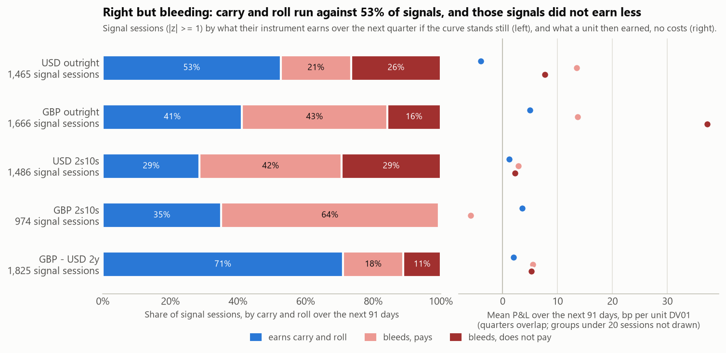
Figure 8. Left: each sleeve’s signal sessions by their carry and roll over the next quarter: in the position’s favour (blue), against it but expected to be paid back as the gap closes (pink), or against it and not (red). Right: what each group then earned over the next 91 days, before costs.
Figure 8 shows that carry and roll ran against 53% of the signals, and those signals didn’t earn less. The right but bleeding moniker best applies to GBP outrights and USD 2s10s. For others, such as USD outright and GBP 2s10s, they are wrong and bleeding. GBP – USD 2y collected carry but was wrong on the rate.
To net zero, the rate calls must pay the costs less carry and roll. They earned +1.36% a year against +4.55% needed: 3.3 times short.
Only GBP outright clears. Its position has a correlation of +0.036 with the daily rate move, against a needed +0.022.

Carry filter
The carry filter was specified in advance as a diagnostic. At each entry it asks whether the expected quarter (the share of the gap that has historically closed, plus carry and roll on the rest) is below zero and skips the entry if so. It skips 16 of 104 entries (15%). That lifts the book’s net Sharpe ratio from −0.61 to −0.51 on the common sample, +0.10 with a paired SE of 0.05. The effect is statistically real, about two paired SEs, and economically irrelevant. The book still loses, and the filter stays off in the headline.

Robustness
No single choice turns the loss into a gain: across 13 rows the net Sharpe ratio runs from −0.70 to −0.29 (Figure 9). The aggregate hides the sleeve: GBP outright, the one sleeve that earns in every row, falls from +0.67 to +0.13–0.15 under estimated coefficients.
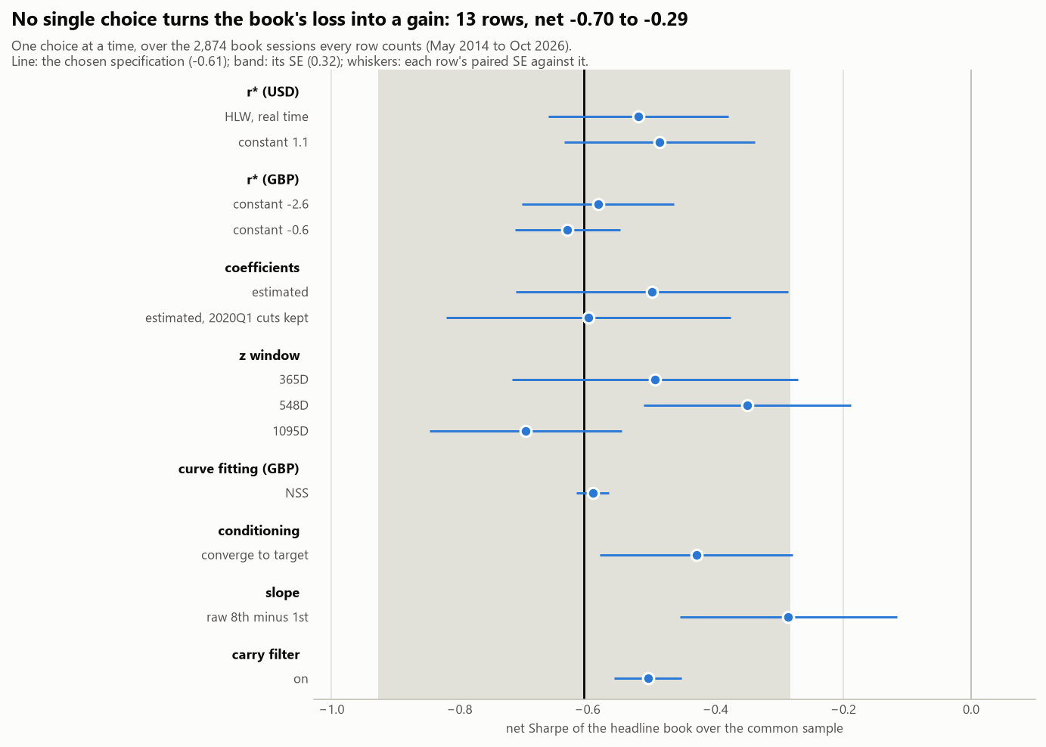
Figure 9. The headline book’s net Sharpe ratio with one choice at a time moved off the chosen specification.

Conclusion
The market prices the policy path below the Fed’s published rule, in USD in every year from 2014 to 2026. Standardized, the gap doesn’t forecast rate changes. In USD it points the wrong way, consistent with the Fed moving toward the market rather than the reverse. GBP outright forecasts, but its gain is concentrated in 2022–23 and depends on a hindsight r* and the coefficients, so it isn’t claimed. The book loses before costs. Costs, half of them maintenance the construction forces, make it worse. No single choice in the robustness grid, and not the carry filter, turns it positive. What would change this is mostly about GBP outright and a sign-flipped USD trade, which leads straight into the list that follows.

What would change my view
Any of these would change my view:
- GBP outright holding up outside 2022–2023
- Quote-based ZQ costs, or calendar-spread roll pricing, that turn GBP net clearly positive (Figure 13)
- A sign-flipped USD trade, betting that the market leads the Fed, that earns out of sample, registered before it is judged
- The rule run on the FOMC’s projected inputs, rather than flat ones, closing most of the level gap
- A more harmonized r* across currencies
- Calendar-anchored signal which would remove the forced roll
- More currencies such as EUR or AUD

Limitations
- GBP r* is a hindsight constant (−1.6%, the 2009–26 average real Bank Rate)
- GBP u* is a constant 4.5%, not a real-time estimate
- UK labor data: LFS was suspended from October 2023 to January 2024
- First z’s after lift-off are standardized against a window that is mostly ELB sessions
- There is no bid-offer data, ZQ’s cost is its tick
- Settlements may be preliminary
- Only 2 currencies currently and 2 hiking cycles
- Overlapping windows inflate t-stats

References
Bank of England. Yield curve data: OIS spot curve. And Monetary Policy Report, market-implied conditioning paths.
Board of Governors of the Federal Reserve System. Monetary Policy Report, the section on monetary policy rules (the balanced-approach and inertial rules).
Board of Governors of the Federal Reserve System. Summary of Economic Projections, longer-run federal funds rate median, 2012–2026.
CME Group. Contract specifications: 30-Day Federal Funds futures (ZQ) and One-Month SOFR futures (SR1).
Congressional Budget Office. Noncyclical rate of unemployment (FRED series NROU), real-time vintages via ALFRED, Federal Reserve Bank of St. Louis.
Holston, K., Laubach, T., and Williams, J. C. (2017). “Measuring the natural rate of interest: International trends and determinants.” Journal of International Economics 108: S59–S75. Real-time estimates from the Federal Reserve Bank of New York.
Office for National Statistics. CPI 12-month rate (D7G7) and LFS unemployment rate (MGSX).
Piazzesi, M., and Swanson, E. T. (2008). “Futures prices as risk-adjusted forecasts of monetary policy.” Journal of Monetary Economics 55(4): 677–691.
Taylor, J. B. (1993). “Discretion versus policy rules in practice.” Carnegie-Rochester Conference Series on Public Policy 39: 195–214.

Appendix A: constructing the market path

USD: the path from Fed Funds Futures
Each ZQ contract (CME 30-Day Fed Funds Futures) settles to the arithmetic average of every calendar day of its delivery month. Due to this, each contract month is one linear equation in the regime rates, each weighted by its share of the month’s days. These contracts are priced across months and regimes using joint least squares (Figure 10). A regime spans several contract months, and each month mixes several regimes. They must be solved together to ensure consistency. However, an issue arises in how information is captured by these contracts. Mid-month, part of the contract is already history. To reflect this, days whose EFFR (Effective Fed Funds Rate) is published enter this as known numbers. This process of substituting in known days creates an additional challenge. When the next meeting is days away, the rate from today until then lives in a few days of the front contract, and price noise in that contract is multiplied by days-in-month over days-left. To address this, contracts below a threshold are pinned to the last fixing when it is shorter than 10 days. Measured against the actual decision on 46 announcement days since 2021, the error in the implied steps fell sharply, from 5.8 bp to 0.5 bp on average, and from 34 bp to 1.6 bp at worst.
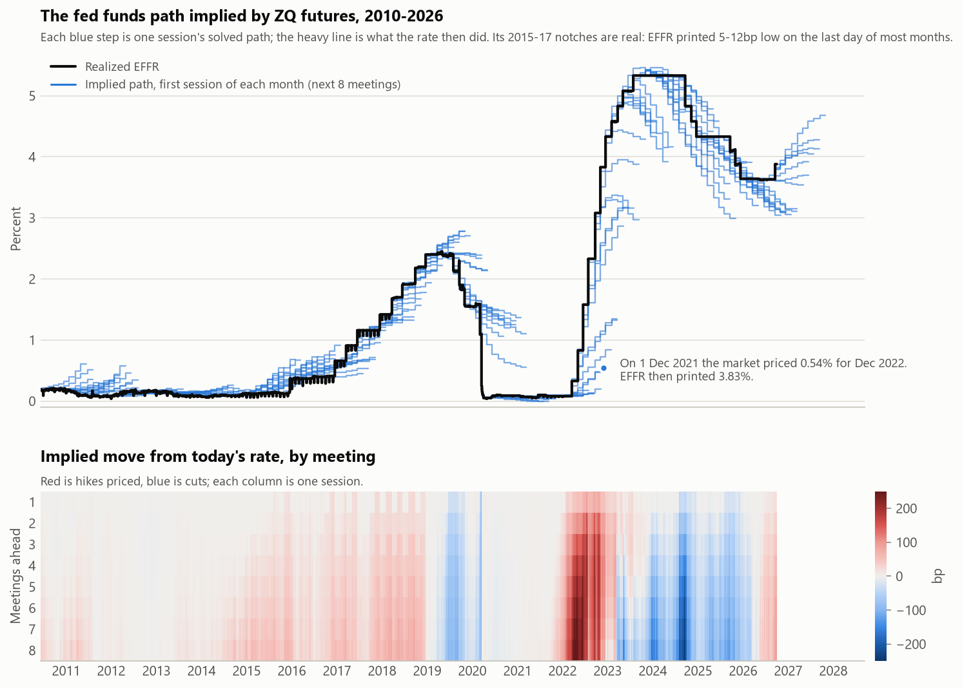
Figure 10. The fed funds path implied by ZQ futures, and the move priced at each meeting.
To check the result, I compare it with SR1 (CME One-Month SOFR Futures). For each session I average the ZQ-implied EFFR path over each SR1 contract month and solve for the constant spread that reprices the SR1 settle: the SOFR – EFFR basis the two markets imply together. I then compare it with the basis later realized (Figure 11). Over 2,116 sessions it misses by +0.52 bp on average, 1.86 bp in absolute terms, and is within 3 bp on 80% of them. Two independent markets agree to within about 2 bp, so the ZQ path is not an artefact of the solver.
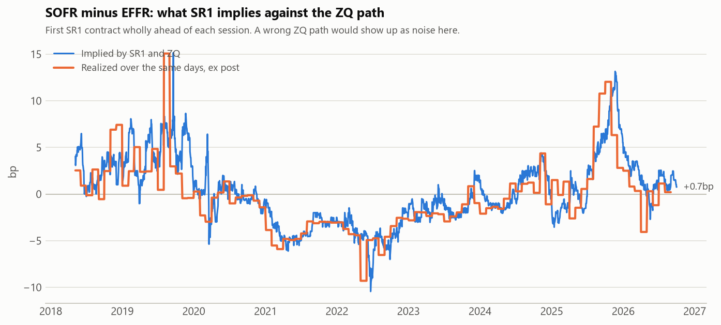
Figure 11. The SOFR − EFFR basis implied jointly by SR1 and the ZQ path.

GBP: the path from the Bank of England’s OIS curve
There is no ZQ outside the US. For GBP, the Bank of England publishes a fitted OIS (Overnight Index Swap) spot curve. I interpolate its log discount factors, and the expected rate between two meetings is the forward over that window (Figure 12).
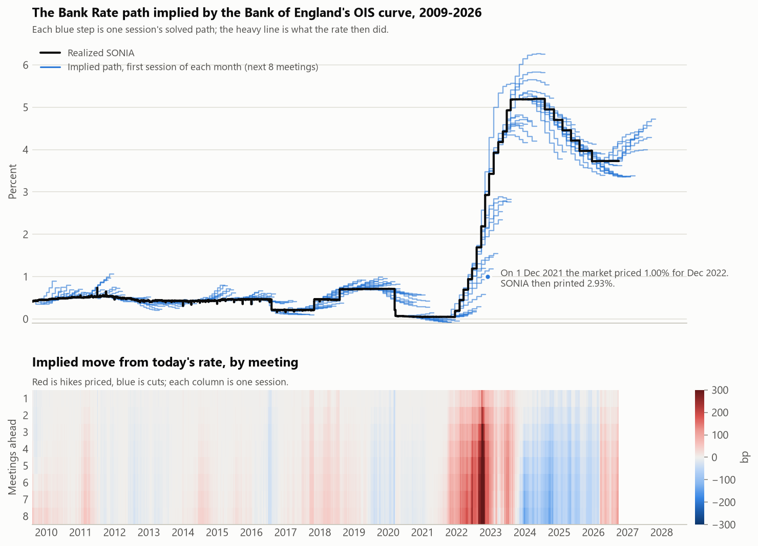
Figure 12. The Bank Rate path implied by the Bank of England’s OIS curve, and the move priced at each meeting.
This is validated against the MPR (Monetary Policy Report) conditioning path. My GBP path is a step function that moves on each meeting’s effective date. The Bank of England averages its smooth instantaneous forward curve, which prices prior to the meeting. In a quarter where there is a hike priced, the Bank’s average ends higher and with a cut, lower. The differences correlate −0.59 with the move priced inside the quarter. Across 29 reports covering 87 quarters, there is a mean absolute difference of 1.00 bp, mean signed difference of −0.46 bp, and worst 7.2 bp. This leaves a known definitional difference, not an error.

Appendix B: cost sensitivity by sleeve
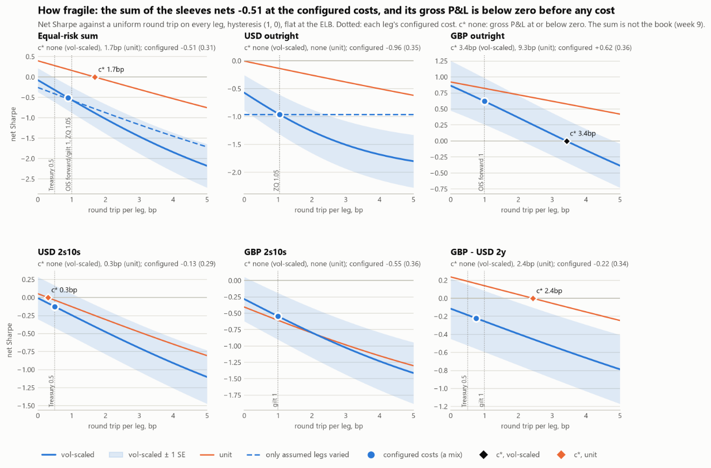
Figure 13. Net Sharpe ratio against a uniform round-trip cost, by sleeve (the sum of the sleeves, not the book).
Coverage: ZQ 99.68% of Fed business days. 0 solver failures in either currency.

